Experiment 11: Nmap Timing and Performance Commands in Kali Linux
Aim
To execute and study Nmap timing and performance commands in Kali Linux using aggressive speed scanning (-T4) and insane speed scanning (-T5).
Algorithm
- Start Kali Linux and open the terminal.
- Check whether Nmap is installed using nmap --version.
- Execute the aggressive speed scan using nmap -T4 127.0.0.1.
- Execute the insane speed scan using nmap -T5 127.0.0.1.
- Observe and compare the scan results.
Commands
i) Aggressive speed scan
nmap -T4 127.0.0.1
ii) Insane speed scan
nmap -T5 127.0.0.1
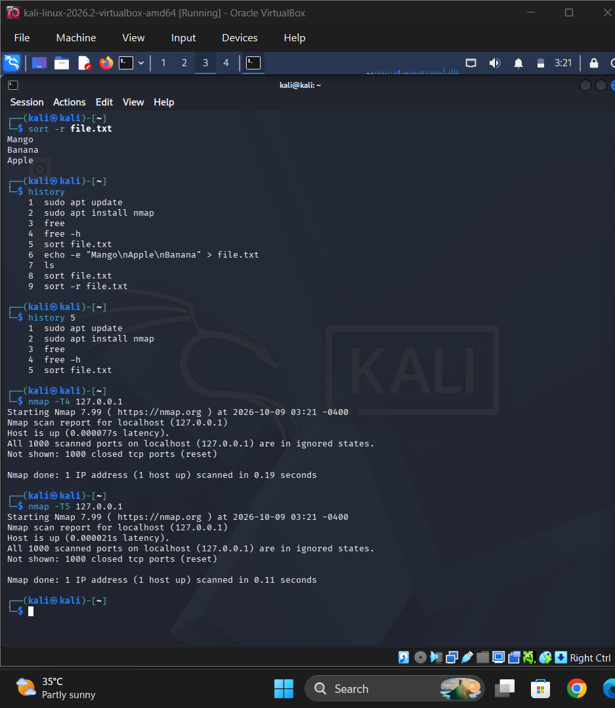
Result
The Nmap -T4 and -T5 timing options were executed to demonstrate aggressive and insane speed scanning in Kali Linux.

